|  |
| --- |
| Ricky Ramnath |

Humber College Parts Crib Management Solution

Status

/1 Hardware present?

/1 Title Page

/1 Declaration of Joint Authorship

/1 Proposal (500 words)

/1 Executive Summary

# Declaration of Joint Authorship

We, Student A, Student B, and Student C, confirm that this work submitted is the joint work of our group and is expressed our own words. Any uses made within it of the works of any other author, in any form (ideas, equations, figures, texts, tables, programs), are properly acknowledged at the point of use. A list of the references used is included. The work breakdown is as follows: Each of us provided functioning, documented hardware for a sensor or effector. Student A provided RFID Scanner. Student B provided GPS Sensor. Student C provided 12- Button Keypad. In the integration effort Student A is the lead for further development of our mobile application, Student B is the lead for the Hardware, and Student C is the lead for connecting the two via the Database.

# Proposal

We have created a mobile application, worked with databases, completed a software engineering course, and prototyped a small embedded system with a custom PCB as well as an enclosure (3D printed/laser cut). Our Internet of Things (IoT) capstone project uses a distributed computing model of a smart phone application, a database accessible via the internet, an enterprise wireless (capable of storing certificates) connected embedded system prototype with a custom PCB as well as an enclosure (3D printed/laser cut), and are documented via this technical report targeting OACETT certification guidelines.

Intended project key component descriptions and part numbers  
Development platform:   
Sensor/Effector 1: RFID Scanner  
Sensor/Effector 2: GPS Sensor  
Sensor/Effector 3: 12 Button Keypad

We will continue to develop skills to configure operating systems, networks, and embedded systems using these key components to create an easier and more efficient method for allowing students to borrow parts from The Parts Crib. This project consists of both a web application and a mobile application with our sensors/effectors. The mobile application provides convenient access for students. This will be beneficial to students as they will be able to utilize the app to find parts that are available. They will be able to view the inventory of available parts which they can borrow if they wish, by using their student credentials. The web application will be utilized mainly by administrative users to keep track of inventory. The overall goal of this project is to avoid overcrowding in The Parts Crib during peak hours of the lab, keep track of parts that have yet to be returned by certain students based on their student credentials and to keep track of the remaining inventory. The RFID Scanner will be used to scan in and out parts that will be recorded on the online database which helps to provide inventory status. The GPS Sensor will prioritize the orders by location and help to identify a more specific location for The Parts Crib. The 12 Button Keypad will be used to get new registered users to type in a specific randomly generated code into the application upon registration to verify that they identify as a Humber College Student.

Our project description/specifications will be reviewed by, _____, ideally an employer in a position to potentially hire once we graduate. They will also ideally attend the ICT Capstone Expo to see the outcome and be eligible to apply for NSERC funded extension projects. This typically means that they are from a Canadian company that has been revenue generating for a minimum of two years and have a minimum of two full time employees.

The small physical prototypes that we build are to be small and safe enough to be brought to class every week as well as be worked on at home. In alignment with the space below the tray in the Humber North Campus Electronics Parts kit the overall project maximum dimensions are 12 13/16" x 6" x 2 7/8" = 32.5cm x 15.25cm x 7.25cm.

Keeping safety and Z462 in mind, the highest AC voltage that will be used is 16Vrms from a wall adapter from which +/- 15V or as high as 45 VDC can be obtained. Maximum power consumption will not exceed 20 Watts. We are working with prototypes and that prototypes are not to be left powered unattended despite the connectivity that we develop.

# Executive Summary

Explain what accomplishments are described by this document and why your product should be purchased and you should be hired by an investor.

Contents

Declaration of Joint Authorship 3

Proposal 5

Executive Summary 7

List of Figures 11

1.0 Introduction 13

1.1 Scope and Requirements 13

2.0 Background 15

3.0 Methodology 17

3.1 Required Resources 17

3.1.1 Parts, Components, Materials 17

3.1.2 Manufacturing 17

3.1.3 Tools and Facilities 17

3.1.4 Shipping, duty, taxes 17

3.1.5 Time expenditure 17

3.2 Development Platform 17

3.2.1 Mobile Application 17

3.2.2 Image/firmware 19

3.2.3 Breadboard/Independent PCBs 19

3.2.4 Printed Circuit Board 21

3.2.5 Enclosure 22

3.3 Integration 23

3.3.1 Enterprise Wireless Connectivity 24

3.3.2 Database Configuration 24

3.3.3 Security 24

3.3.4 Testing 24

4.0 Results and Discussions 25

5.0 Conclusions 27

6.0 References 29

7.0 Appendix 31

7.1 Firmware code 31

7.2 Application code 31

# List of Figures

Figure 1. By Android Studio - https://developer.android.com/studio/, CC BY-SA 4.0, https://commons.wikimedia.org/w/index.php?curid=74094999 19

Figure 2. Initial schematic. This work is a derivative of "http://fritzing.org/parts/" by Fritzing, used under CC:BY-SA 3.0. 20

Figure 3. This work is a derivative of "http://fritzing.org/parts/" by Fritzing, used under CC:BY-SA 3.0. 20

Figure 4. Breadboard prototype. 21

Figure 5. PCB design This work is a derivative of "http://fritzing.org/parts/" by Fritzing, used under CC:BY-SA 3.0. 22

Figure 6. Humber Sense Hat Prototype PCB. 22

Figure 7. Example enclosure. 23

# 1.0 Introduction

This technical report presents the methods and processes of how we achieved our project result. Knowing who arrives, borrows parts and having easy access to our inventory are key parts of the parts crib management solution. Some of this projects policy require that you track how long students are borrowing parts for or that all students participating return each part at a certain time of day that is specified. This will additionally be able to help the administrative side by verifying that individuals borrowing parts are Humber College students that have an official student ID card. By recording sign-out times, it’s easy to track who borrows parts when and attend to students who are over their time limit or that have not yet returned said parts. Having a GPS sensor to track activity from a certain parts crib location and prioritize orders will also help with an efficient way of managing the parts crib. To further enhance security, the keypad will allow students to enter the specific code that will be generated by the application to ensure verification of Humber students. Finally, the RFID scanner will be a critical component of this project to help keep track of inventory by uploading information to the database for a more accurate count and to easily monitor activity. The application will provide a precise GPS location of the parts cribs, inventory status, and peak times for labs. The application will also allow students to create a cart of parts they will need for their labs and place orders from anywhere with a Wi-Fi connection. This system is meant for loan out companies and small businesses with inventory that will need to be loaned out to employees or customers. Specifically, this system will be prototyped and used by the Humber College Parts Crib.

## 1.1 Scope and Requirements

Describe what will be done. It is an Internet of Things (IoT) capstone project that uses a distributed computing model of a smart phone application, a database accessible via the internet, an enterprise wireless (capable of storing certificates) connected embedded system prototype with a custom PCB as well as an enclosure (3D printed/lasercut), and is documented via an OACETT certification acceptable technical report. Also describe the limits of the project and what will not be done (CSA testing) in this project. Include the development platform specifications and any other hardware specifications possibly organized in point form, the Android device requirements, and database specifications/protocols.

Report

/1 Hardware present?

/1 Introduction (500 words)

/1 Scope and Requirements

/1 Background (500 words)

/1 References

# 2.0 Background

We would like to thank mentor Diego Magalhães from AWS for supporting this project. This section is to include at least three references, here is an example of an APA citation of a website (OACETT, 2017) followed by a sentence citing an Article in a Periodical, a Book, and a Journal Article. Humber is planning to host an internal DeepRacer event using an existing example of machine learning (Robuck, 2018), artificial intelligence (Media, O., 2019), and internet connected servers (Kinsella, 2019).

# 3.0 Methodology

## 3.1 Required Resources

Report

/1 Parts/components/materials (500 words)

/1 PCB, case (500 words)

/1 Tools, facilities (500 words)

/1 Shipping, duty, taxes (250 words)

/1 Working time versus lead time (250 words)

### 3.1.1 Parts, Components, Materials

### 3.1.2 Manufacturing

### 3.1.3 Tools and Facilities

### 3.1.4 Shipping, duty, taxes

### 3.1.5 Time expenditure

Working time versus lead time.

## 3.2 Development Platform

### 3.2.1 Mobile Application

Status

/1 Hardware present?

/1 Memo by student A + How did you make your Mobile Application? (500 words)

/1 Login activity

/1 Data visualization activity

/1 Action control activity

Include screenshots such as Figure 1. Testing. Progress.

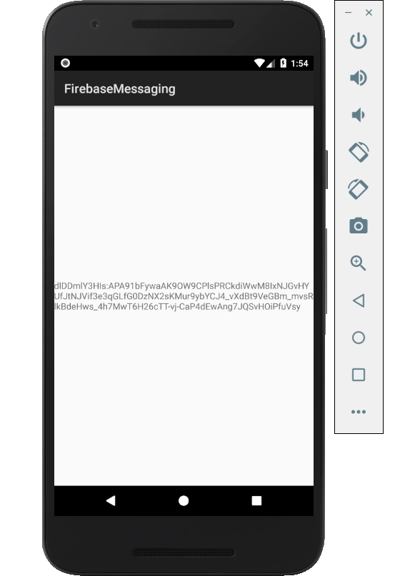

Figure 1. By Android Studio - https://developer.android.com/studio/, CC BY-SA 4.0, https://commons.wikimedia.org/w/index.php?curid=74094999

### 3.2.2 Image/firmware

Status

/1 Hardware present?

/1 Memo by student B + How did you make your Image/firmware? (500 words)

/1 Code can be run via serial or remote desktop

/1 Wireless connectivity

/1 Sensor/effector code on repository

### 3.2.3 Breadboard/Independent PCBs

Status

/1 Hardware present?

/1 Memo by student C + How did you make your hardware? (500 words)

/1 Sensor/effector 1 functional

/1 Sensor/effector 2 functional

/1 Sensor/effector 3 functional

The initial schematic design, Figure 2, based on datasheets (Bosch Sensortec, 2019) led to a breadboard layout Figure 3 that was realized Figure 4.

How did you build your Prototype: Breadboard?

Then a PCB was designed, Figure 5, and populated (Figure 6). Bill of Materials, Case, Time commitment. Testing. Progress.

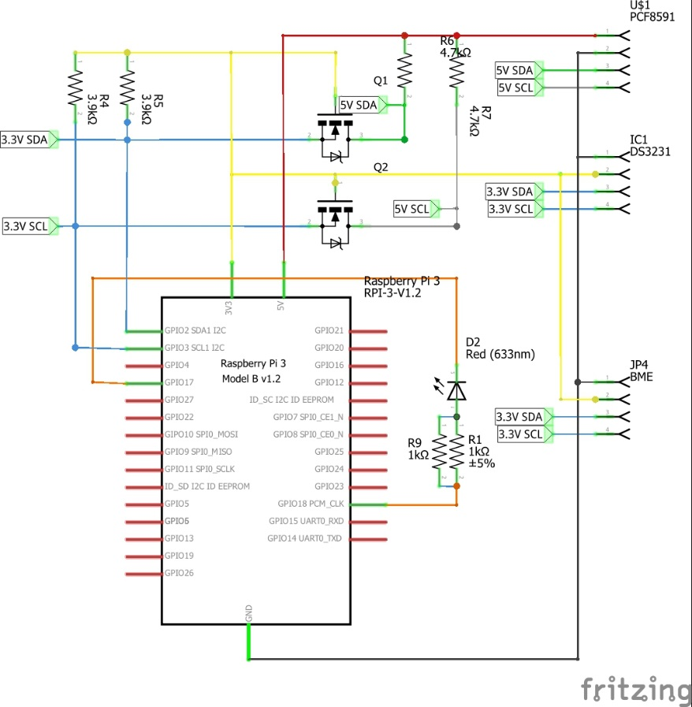

Figure 2. Initial schematic. This work is a derivative of "http://fritzing.org/parts/" by Fritzing, used under CC:BY-SA 3.0.

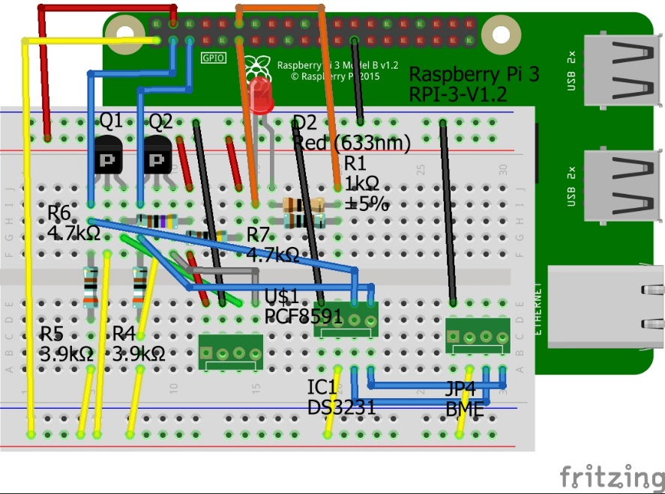

Figure 3. This work is a derivative of "http://fritzing.org/parts/" by Fritzing, used under CC:BY-SA 3.0.

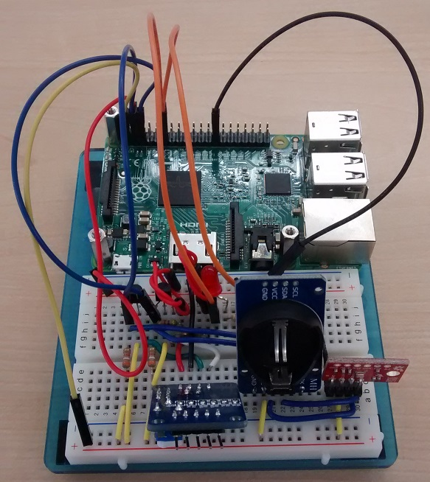

Figure 4. Breadboard prototype.

### 3.2.4 Printed Circuit Board

Demo

/1 Hardware present?

/1 PCB Complete and correct

/1 PCB Soldered wire visible but trim, no holes or vacancies

/1 PCB Tested with multimeter

/1 PCB Powered up

How did you build your Prototype: PCB?

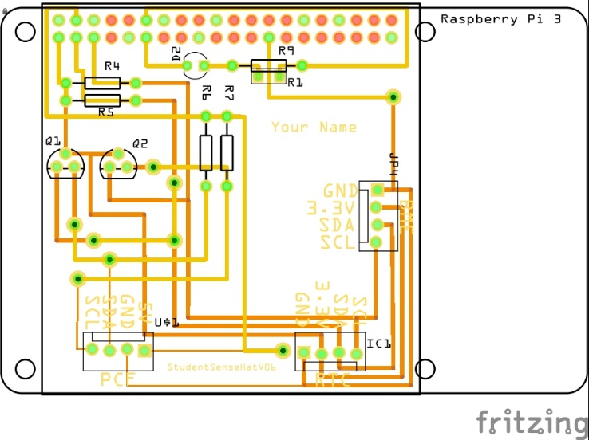

Figure 5. PCB design This work is a derivative of "http://fritzing.org/parts/" by Fritzing, used under CC:BY-SA 3.0.

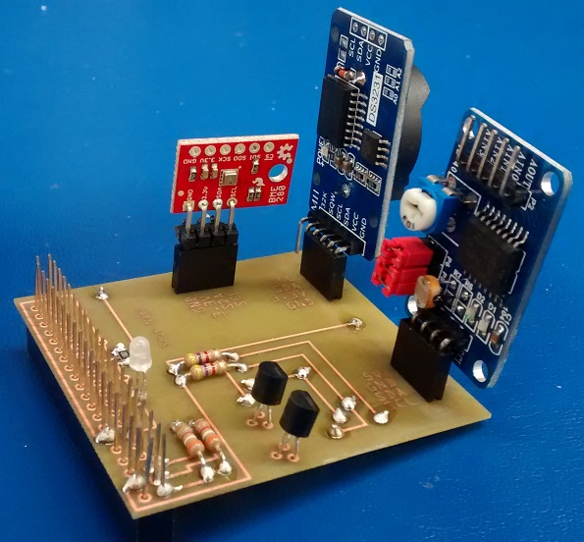

Figure 6. Humber Sense Hat Prototype PCB.

### 3.2.5 Enclosure

Demo

/1 Hardware present?

/1 Case encloses development platform and custom PCB.

/1 Appropriate parts securely attached.

/1 Appropriate parts accessible.

/1 Design file in repository, photo in report.

How did you build your Prototype: Case?

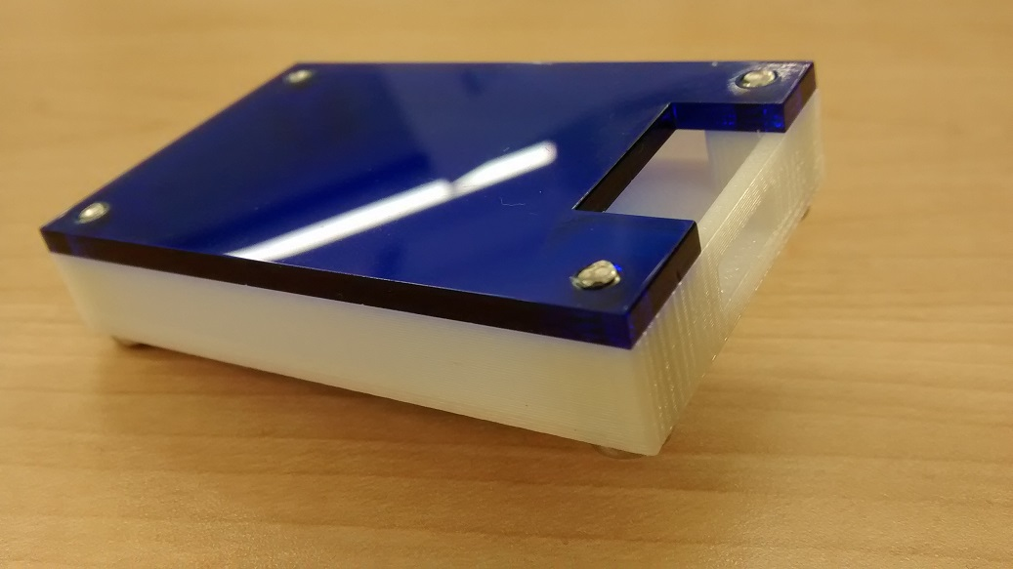

Figure 7. Example enclosure.

## 3.3 Integration

Demo

/1 Hardware present?

/1 Data sent by hardware

/1 Data retrieved by mobile application

/1 Action initiated by mobile application

/1 Action recieved by hardware

Report

/1 Enterprise wireless connectivity (250)

/1 Database configuration (250 words)

/1 Security considerations (500 words)

/1 Unit testing (900 words)

/1 Production testing (100 words)

### 3.3.1 Enterprise Wireless Connectivity

How did you make a Database accessible by both your Prototype and Mobile Application?

### 3.3.2 Database Configuration

### 3.3.3 Security

### 3.3.4 Testing

Unit testing and Production testing.

# 4.0 Results and Discussions

Is your prototype perfect? What did you learn?

# 5.0 Conclusions

If you were making 1000 of these.

Report

/1 Hardware present?

/1 Checklist truthful

/1 Valid Comments

/1 Results and Discussion (500 words)

/1 Conclusion

# 6.0 References

Bosch Sensortec. (2019, July). *BME680 - Datasheet.* Retrieved from Robert Bosch GmbH: https://ae-bst.resource.bosch.com/media/_tech/media/datasheets/BST-BME680-DS001.pdf

Kinsella, J. (2019). Five trends predicted for the cloud industry in 2019. *Software World*, 50(1), 11.

Media, O. (2019). *O'Reilly artificial intelligence conference 2019 - San Jose, California.* California: O'Reilly Media, Inc.

OACETT. (2017, March). *I need to Complete a Technology Report*. Retrieved from The Ontario Association of Certified Engineering Technicians and Technologists: https://www.oacett.org/Membership/Technology-Report-and-Seminar

Robuck, M. (2018, 11). AWS goes deep and wide with machine learning services and capabilities. *Fierceinstaller*.

# 7.0 Appendix

## 7.1 Firmware code

Demo

/1 Hardware present?

/3 Code runs concurrently for all sensors/effectors

/1 Project repository contains integrated code

Status

/1 Memo including updates

/1 Financial update

/1 Progress update

/1 Modified Code Files in Appendix

/1 Link to Complete Code in Repository

## 7.2 Application code

Demo

/1 Hardware present?

/1 Memo by student A

/1 Login activity

/1 Data visualization activity

/1 Action control activity

Report

/1 Login activity

/1 Data visualization activity

/1 Action control activity

/1 Modified Code Files in Appendix

/1 Link to Complete Code in Repository